OOP Project Report

21K-4673 Khalid, 21K-4844 Zeeshan Ahmed (Team leader), 21K-4518 Aqib Shah

# Problem Statement:

In order to help people to make easy their life, we have combined multiple features like Notepads, Calculator, games, etc. into a single console-based OS.

# Introduction:

We have opted to design an operating system that is focused on automating multiple tasks with great efficiency and precision. The operating system will offer multiple features of an ordinary operating system and will function as an intermediate virtual machine. The main objective of this project is to utilize the maximum functionalities of OOP (Object Oriented Programming) to come up with a suitable solution to reduce the complexity and hectic work of using multiple applications to perform basic tasks.

# Existing Problem:

It is not a proper interface but console-based and it is not global and there is no database to store our data.

# Proposed Solution/ Changes:

We will try to use a proper database to store information and also make other major changes to improve and innovate.

# Tools & Technology:

Some renowned technologies we used included:

* Classes and Objects
* Constructors and Destructors
* Conditional and looping structures
* Filing and data storage systems
* Abstraction
* Encapsulations
* Template and Generics
* Inheritance(All its Types)
* Polymorphism
* Exception Handling

# Timeline or Breakup:

## First Meeting (May 8):

Zeeshan => Tic TAC Toe game, Aqib=> Notepad, Khalid=> Scientific Calculator

The deadline was set for May 15 Sunday. Everyone successfully submitted Tasks to Zeeshan the tasks of meeting 1.

## Second Meeting (May 15):

Zeeshan presented the group with the whole class diagram of the project.

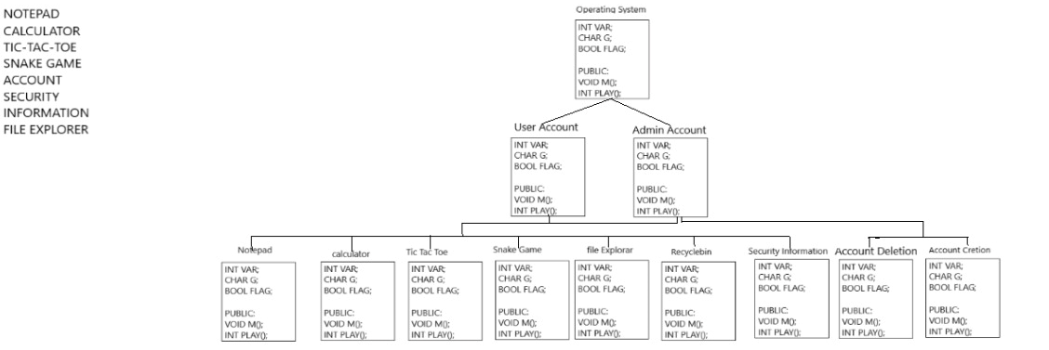

Khalid=> Security, Zeeshan=> Accounts, Aqib=>File Explorer

All Files were submitted on time on May 22.

## Third Meeting (May 24)

The project was finalized.